Prioritizing Cancer Screening within Health Systems Model Policy

Rationale
This policy was created to assist healthcare facilities in establishing a process for all patients who are eligible for breast, cervical, lung and colorectal cancer screening. It should be used as a tool for healthcare facilities to establish systems change and institutionalize cancer screening interventions into routine clinical care.

Cancer was the second leading cause of death in South Dakota in 2018, with over 4,800 cancer cases diagnosed and 1,661 deaths. This equates to one in four deaths in South Dakota being attributable to cancer. More than half of the cancers diagnosed in South Dakota are lung, prostate, female breast, colorectal, and melanoma cancer. These five primary sites accounted for 55 percent of all cancers diagnosed in 2018.

The burden of cancer in South Dakota disproportionately affects certain populations. National statistics show a higher impact on certain racial and ethnic groups. This difference is similarly reflected in South Dakota’s data. The 2018 age-adjusted cancer mortality rate was 144.0/100,000 for whites and 257.8/100,000 for American Indians. A disparity is also found between genders, with the greatest cancer impact on males.¹

In 2008, an estimated 4.1 percent (33,200) of South Dakotans had some form of cancer. The cost of cancer in South Dakota was approximately $377 million for all payers combined. The estimated, average cost per South Dakotan was $11,360. Persons age 65 and older had a majority of the cancer expenditures with $274 million.²

Completing recommended cancer screening tests may find breast, cervical, lung and colorectal cancers early, when treatment is likely to work best.³ In 2014-2018, 78 percent of white females ages 40 and older, in South Dakota, had received a mammogram within the past two years compared to 74 percent of American Indian females. In 2014-2018, 82 percent of white females, ages 21-65, had completed a Pap test within the past three years. This percentage was lower than that for American Indian females (84 percent). A greater disparity between whites and American Indians exists for colorectal cancer screening. Only 58 percent of American Indians, ages 50-75, were up-to-date with recommended screening compared to 68 percent of whites.⁴
All of these rates fall short of the South Dakota Comprehensive Cancer Control State Plan 2025 goals for colorectal, breast, and cervical cancer screening⁵:
- Increase the percentage of adults ages 45-75 in South Dakota up-to-date with recommended colorectal cancer screening from 69.1% to 80% by 2025.
- Increase the percentage of women ages 40 and older in South Dakota who have had a mammogram in the past two years from 82% to 86% by 2025.
- Increase the percentage of women ages 21 to 65 in South Dakota who have received a Pap test within the past three years from 80.7% to 85% by 2025.

Provider recommendations are critical in cancer screening
The advice of a doctor to complete cancer screening has a well-documented, demonstrated positive effect, specifically for breast, cervical, lung and colorectal cancer screening. According to Sarfaty, “The magnitude of a clinician’s impact is considerable: State surveys have shown that 90 percent of people who reported a physician recommendation for CRC testing were screened vs. 17 percent of those who reported no provider recommendation, and 72 percent of those whose physician recommended a stool blood test completed it vs. 8 percent of those whose physician had not.”⁶

Model Policy for Implementation
Early detection and screening are the best ways to prevent or find cancer in the earliest stages when treatment often leads to a cure. The first step to creating a healthcare facility that supports cancer screening for all patients is to utilize this model policy in its entirety or adapt this model policy to support patient screening.

- [Healthcare facility] is committed to increasing cancer screening and working toward the South Dakota Cancer Plan 2025 goals (listed above) for cervical cancer [and/or] breast cancer [and/or] lung [and/or] colorectal cancer.
- [Healthcare facility] is committed to providing its healthcare providers, nurses, therapists and other staff with evidence-based information and education that they need to integrate cancer screening into their practice.
- [Healthcare facility] is committed to providing its patients with evidence-based education and motivational information that they need to make decisions about screening.
- [Healthcare facility] is committed to implementing evidence-based interventions to help ensure that the screening process does not break down, resulting in missed opportunities to screen people. [Healthcare facility] will utilize screening reminder systems for healthcare providers and patients.
- [Healthcare facility] is committed to providing test results to patients, appropriate follow-up for abnormal results, and diagnostic and treatment resolution.

Colorectal Cancer
- [Healthcare facility] will offer colorectal cancer screening to patients ages 45 to 75 who are at average risk and asymptomatic of colorectal cancer.
- [Healthcare facility] encourages providers to offer multiple options so that screening is completed. [Healthcare facility] will offer U.S. Preventive Services Task Force (USPSTF) recommended screenings which include:
- Colonoscopy every 10 years; or
- High sensitivity fecal occult blood test (FOBT) or fecal immunochemical test (FIT) annually; or
- Flexible sigmoidoscopy every five years combined with high-sensitivity FOBT or FIT every three years; or
- FIT-DNA test every one to three years; or
- CT Colonography every five years.

- [Healthcare facility] will assess patient risk and will recommend individuals at a high or increased risk of colorectal cancer be screened earlier and/or more frequently. The following conditions increase a patient’s risk:
- Personal history of colorectal cancer or adenomatous polyps
- Personal history of inflammatory bowel disease (ulcerative colitis or Crohn’s disease)
- Strong family history of colorectal cancer or polyps
- Known family history of hereditary colorectal cancer syndrome such as familial adenomatous polyposis (FAP) or hereditary non-polyposis colon cancer (HNPCC)
- [Healthcare facility] discourages the use of single sample guaiac FOBT obtained during digital rectal exam as a primary screening for colorectal cancer.

Cervical Cancer
- [Healthcare facility] will screen average risk, asymptomatic women ages 21 to 65 for cervical cancer according to the USPSTF recommended tests at the following intervals:
- Cytology (Pap smear) every three years
- For women ages 30 to 65 who want to lengthen the screening interval, screening with a combination of cytology and human papillomavirus (HPV) testing or only HPV testing every five years.

Breast Cancer
- [Healthcare facility] will assess female patient risk for breast cancer. Female patients at average risk will be offered breast cancer screening based on either the USPSTF recommendations or the American Cancer Society recommendations. (See below the recommendations that are most appropriate for the healthcare facility’s patients.)
USPSTF Recommendations:
- Biennial screening mammography for women ages 50 to 74.
American Cancer Society Recommendations:
- Annual mammography for women ages 40 and older
- Female patients in their 20s and 30s will have a clinical breast examination as part of a periodic health examination, preferably at least every three years.
- Asymptomatic women ages 40 and older will continue to receive a clinical breast examination as part of a periodic health examination.
- Female patients at increased risk of breast cancer will be consulted on screening strategies, such as earlier initiation of screening, shorter screening intervals, or additional screening modalities, such as ultrasound or magnetic resonance imaging.

Lung Cancer
- [Healthcare facility] will offer lung cancer screening with low-dose computed tomography (LDCT) to patients aged 55 to 80 years who have a 30 pack-year smoking history and currently smoke or have quit within the past 15 years.
- [Healthcare facility] will assess patient risk and will discontinue screening once a person has not smoked for 15 years or develops a health problem that substantially limits life expectancy or the ability or willingness to have curative lung surgery.
Implementation
These guidelines from the American Cancer Society focus on systems change within the healthcare facility. The information below provides suggestions for implementing this policy and increasing screening rates.
- Establish a diverse team representing all relevant roles within the clinic to create momentum and measured outcomes.
- Have the team assess data to determine current screening status, develop goals and objectives, conduct quality improvement cycles, and evaluate and measure impact.
- Recognize the need for established systems to ensure all eligible patients receive a cancer screening recommendation.
- Make a Recommendation
Evidence shows a provider recommendation is the most influential factor in a patient’s decision to be screened. Reviewing family and personal medical history provides insight to determine the appropriate screening recommendation and overall health care. Engaging patients in the decision by providing education on multiple choices from the recommended screening guidelines increases patient compliance. Appropriate documentation decreases potential duplication of testing and ensures additional diagnostic evaluation is conducted through referral or follow-up based on test results.
- Develop a Screening Policy
A standard course of action established within a clinic improves screening consistency and promotes screening as a priority within the clinic.
- Be Persistent with Reminders
Reminders are evidence-based and proven to be effective when directed at patients, providers or both. Evidence indicates patient compliance increases with the use of routine phone calls and direct mail reminders for appointments. Methods to remind and encourage providers to engage patients in conversations regarding cancer screening includes chart prompts, electronic medical record alerts, and routine assessment and feedback of provider performance regarding screening compliance.
- Measure Progress
Data provides objective and relevant insights to determine progress and impact. As the practice continues to improve upon existing evidence-based interventions; taking time to monitor progress and prioritize quality improvement efforts will have positive results. Reviewing patient demographics to consider target and disparate populations also ensures appropriate interventions and tools are being used to reach the screening goals. Data collection to establish a baseline for future comparison is essential for measuring the effectiveness of quality improvement activities. Regular progress reporting will lead to the development of best practices to improve patient outcomes and staff efficiency.
See Appendix A for workflow examples to assist healthcare facility staff to implement this model policy.
Compliance
Use the above policy language as a guide for your clinic or hospital. Implementing a policy that will fit your facility and benefit your patients is the overall goal and policy compliance should be considered for this purpose. Your quality improvement committee may be the perfect group to ensure this policy will remain a priority.

Final Statement
By implementing this model policy in its entirety or choosing to tailor this policy to your facility’s needs, you are taking a great first step in improving cancer screening for your patients.

Policy Contact
Contact [Healthcare facility staff] with questions or concerns about the policy.
Effective Date: The policy is effective [date].
Policy Monitoring and Review
The [Healthcare facility] will evaluate and revise this policy on an [annual] basis.
Review Date: The policy will be reviewed [annually].

Definition of Terms
- Colorectal Cancer: Cancer of the colon or rectum.
- Colonoscopy: A procedure where the doctor uses a long, thin, flexible, lighted tube to check for polyps or cancer inside the rectum and the entire colon. During the test, the doctor can find and remove most polyps and some cancers. Colonoscopy also is used as a follow-up test if anything unusual is found during one of the other screening tests.
- Sigmoidoscopy: A procedure where the doctor puts a short, thin, flexible, lighted tube into the rectum. The doctor checks for polyps or cancer inside the rectum and lower third of the colon.
- Mammography: X-ray of the breast used to look for signs of breast cancer.

- Low-Dose Computed Tomography (LDCT): scanning combines special x-ray equipment with sophisticated computers to produce multiple, cross-sectional images or pictures of the inside of the body. Low-dose CT uses less ionizing radiation than a conventional CT scan.
- FIT-DNA test: Combines stool test with a test that detects altered DNA in the stool.
- CT Colonography: Computed tomography colonography, also called virtual colonoscopy, uses X-rays and computers to produce images of the entire colon, which are displayed on a computer screen for the doctor to analyze.

Resources

Common Sense Colorectal Cancer Screening Recommendations at a Glance
https://www.cancer.org/content/dam/cancer-org/cancer-control/en/reports/common-sense-colorectal-cancer-screening.pdf

Comparison of Cervical Cancer Guidelines
https://www.cdc.gov/cancer/cervical/pdf/guidelines.pdf

How to Increase Colorectal Cancer Screening Rates in Practice: A Primary Care Clinician’s Evidence-Based Toolbox and Guide
https://www.cancer.org/content/dam/cancer-org/cancer-control/en/reports/how-to-increase-preventive-screening-rates-in-practice.pdf

What Works: Evidence-Based Interventions for your Community http://www.thecommunityguide.org/about/What-Works-Cancer-Screening-insert.pdf

Steps for Increasing Colorectal Cancer Screening Rates: A Manual for Community Health Centers
http://nccrt.org/wp-content/uploads/0305.60-Colorectal-Cancer-Manual_FULFILL.pdf

References:
- South Dakota Cancer Registry. (April 2021). An Annual report on Cancer Incidence and Mortality Among South Dakotans, 2018. Pierre, SD: South Dakota Department of Health. Retrieved from https://getscreened.sd.gov/documents/2018/2018CancerReport.pdf
- Centers for Disease Control and Prevention (CDC). (2013). Chronic Disease Cost Calculator Version 2. Retrieved from https://www.cdc.gov/chronicdisease/calculator/.
- Centers for Disease Control and Prevention (CDC). (2015). Cancer Prevention and Control. Retrieved from http://www.cdc.gov/cancer/index.htm.
- South Dakota Department of Health (2018). Behavioral Risk Factor Surveillance Survey Data. Pierre, SD: South Dakota Department of Health, Office of Data and Health Statistics.
- South Dakota Cancer Plan: 2021-2025. Retrieved from https://www.cancersd.com/about-us/2021-2025-sd-cancer-plan/

- Sarfaty, M. (2008). How to Increase Colorectal Cancer Screening Rates in Practice: A Primary Care Clinician’s* Evidence-Based Toolbox and Guide 2008. Retrieved from https://www.cancer.org/content/dam/cancer-org/cancer-control/en/reports/how-to-increase-preventive-screening-rates-in-practice.pdf

For more information, contact the SD Department of Health at (605) 773-3737 or visit goodandhealthysd.org.

Questions to Assess Current Cancer Screening Practices

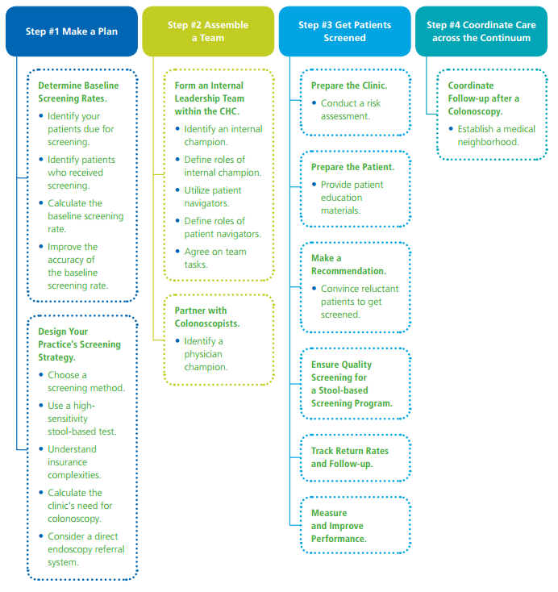
Overview of the Screening Process
http://www.cancer.org/acs/groups/content/documents/document/acspc-044104.pdf

What Works: Cancer Prevention and Control
Evidence-Based Interventions for Your Facility

The Community Preventive Services Task Force has released the following findings on what works in public health to increase breast, cervical, and colorectal cancer screening rates. These findings are compiled in the Guide to Community Preventive Services and listed in the table below. Use the findings to identify strategies and interventions you could use for your facility.

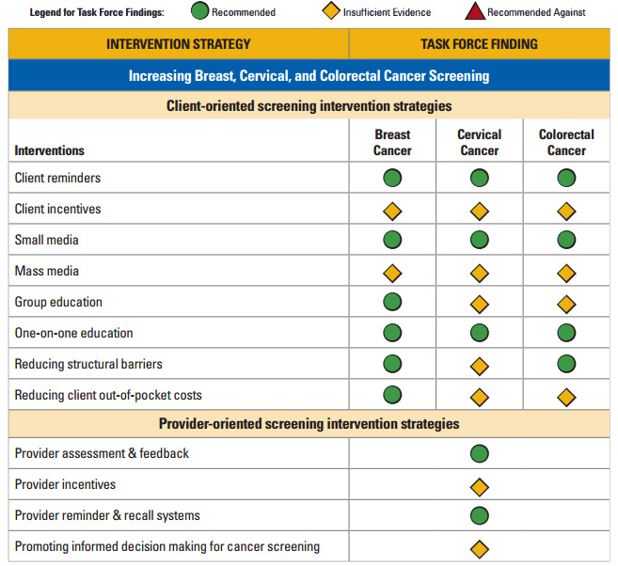
http://www.thecommunityguide.org/cancer/index.html

