Department of Health Distribution Center Fax Form
Billing Code: TCP – 0907001 3049 736 CS E

CVD013 – BCBH Chronic Disease Rack Card (green)
Quantity: #
CVD035 – BCBH Diabetes Rack Card (blue)
Quantity: #
CVD038 – BCBH Chronic Pain Rack Card (pink)
Quantity: #
CVD039 – BCBH Worksite Rack Card (orange)
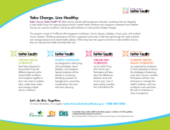
Quantity: #
CVD036 – BCBH Program Flyer
Quantity: #
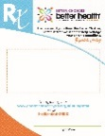
CVD018 – BCBH Rx Pad (each pad has 50 sheets)
Quantity: # Pads
CVD003 – BCBH Workshop Posters (set of 4 different posters)
Quantity: # Sets
Fax order form to: (primary order option)
Department of Health Distribution Center
Attn: Taylor Carlson
Fax: 605-347-9631

Mail completed orders to: (No PO Box numbers)
Click here to enter text.

IF UNABLE TO FAX: email completed form to Alicyn.Even@state.sd.us for assistance

