Department of Health Distribution Center Fax Form
Billing Code: TCP – 0907001 3049 736 CS E

CVD013 – BCBH Chronic Disease Rack Card (green)
Quantity: #

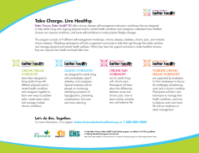
CVD035 – BCBH Diabetes Rack Card (blue)
Quantity: #

CVD036 – BCBH Program Flyer
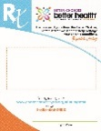
Quantity: #

CVD018 – BCBH Rx Pad (each pad has 50 sheets)
Quantity: # Pads

CVD003 – BCBH Workshop Posters (set of 4 different posters)
Quantity: # Sets

Fax order form to:
Department of Health Distribution Center
Attn: Taylor Carlson
Fax: 605-347-9631
Mail completed orders to: (No PO Box numbers)
Click here to enter text.

For questions, please contact Katie Hill at 605-773-2790 or Katie.Hill@state.sd.us

